Chapter 1
Introduction to Modeling and Simulation

What is simulation?
Simulation is the process of creating and analyzing a digital or mathematical representation of a real-world system, product, or environment in order to predict how it will behave under different conditions. It allows engineers, designers, and researchers to study performance, identify risks, and evaluate outcomes before building a physical prototype or running expensive experiments.
Simulation typically begins by defining the system, selecting the relevant variables, and building a model based on geometry, material properties, forces, motion, or environmental conditions. The model is then run through one or more scenarios, and the results are compared against expected behavior or test data. This process may be repeated many times to refine the design and improve accuracy.
Common types of simulation include structural simulation, fluid flow simulation, thermal simulation, electrical simulation, and dynamic simulation. Each type serves a different purpose: structural simulation helps assess stress and failure points, fluid simulation studies airflow or liquid movement, thermal simulation examines heat transfer, electrical simulation analyzes circuits and power behavior, and dynamic simulation predicts motion, vibration, or system response over time.
In practice, simulation is used across many fields. Automotive engineers use it to test crash performance and aerodynamics, architects use it to study building loads and energy efficiency, manufacturers use it to improve product durability, and medical professionals use it to model treatments or biological processes. It is also widely used in aerospace, robotics, civil engineering, electronics, and product design.
Compared with real-world testing, simulation is often faster, safer, and more cost-effective. It reduces the need for repeated physical prototypes, helps explore more scenarios than would be practical in the real world, and can reveal failure conditions that are difficult or dangerous to reproduce. While physical testing is still important for validation, simulation helps teams make better decisions earlier in the design process.
Today, simulation plays a central role in modern engineering and design. It supports innovation, improves reliability, shortens development cycles, and helps organizations deliver better products with fewer resources. By combining simulation with testing and analysis, teams can understand not just whether something works, but why it works and how it can be improved.

System Concepts
A system is a set of interrelated components working together toward some purpose.
A system is more than a collection of parts: the parts are connected, influence one another, and produce outcomes that would not exist if the parts were isolated.
Key Characteristics:
- Components: Individual parts that make up the system. For example, a computer system includes the processor, memory, storage, input devices, and software.
- Interrelationships: The way components interact or depend on each other. In a hospital, doctors, nurses, equipment, and records must coordinate for patient care to work smoothly.
- Boundary: Defines what is inside and outside the system. A school system includes classrooms, staff, students, and policies, but excludes outside organizations unless they directly influence it.
- Purpose/Goal: The reason the system exists or what it is intended to achieve. A banking system exists to securely manage money, process transactions, and support financial services.
- Input & Output: Systems typically take input, process it, and produce output. A traffic system receives cars, pedestrians, signals, and road conditions as inputs, then produces movement, congestion, or flow as outputs.
- Feedback Mechanism: Helps regulate and improve performance. For example, a thermostat compares room temperature with a target setting and turns heating on or off to maintain comfort.
Why Understanding Systems Matters
Understanding systems helps us see how change in one part can affect the whole. It is useful in engineering, business, ecology, healthcare, and technology because it improves decision-making, problem-solving, and planning. When we understand systems, we can identify bottlenecks, prevent failures, and design better solutions.
System Behavior, Dynamics, and Environment
System behavior refers to how a system acts over time. Some systems are stable and predictable, while others are constantly changing because of internal interactions or outside forces. System dynamics focuses on these changes and how feedback, delays, and dependencies shape outcomes.
Systems also interact with their environment. A system may receive resources, information, or energy from outside and send results back into the environment. For example, an ecosystem interacts with climate, water, and sunlight; a business interacts with customers, suppliers, and competitors.
Simple and Complex Systems
Some systems are simple, with few parts and straightforward relationships. A bicycle is a simple system: pedals, chains, wheels, and brakes work together in a clear way.
Other systems are complex, with many components and unpredictable interactions. An air transportation network is complex because it includes aircraft, airports, weather, schedules, passengers, regulations, and communication systems that all influence one another.
Examples:
- Computer system: Includes hardware and software that work together to process data, run applications, store information, and support user tasks.
- Ecosystem: A natural system made up of living organisms, soil, water, air, and sunlight that interact to sustain life and maintain ecological balance.
- Banking system: A financial system that handles deposits, loans, transfers, interest, security, and customer services while responding to market conditions and regulations.

Components of system

Entity, attribute and activities
An entity represents an object that requires explicit definition. An entity can be dynamic in that it moves through the system, or it can be static in that it serves other entities. In the example, the customer is a dynamic entity, whereas the bank teller is a static entity. An entity may have attributes that pertain to that entity alone. Thus, attributes should be considered as local values. In the example, an attribute of the entity could be the time of arrival. Attributes of interest in one investigation may not be of interest in another investigation. Thus, if red parts and blue parts are being manufactured, the color could be an attribute. Processes that cause system changes are called activities or events. In the bank example, events include the arrival of a customer for service at the bank, the beginning of service for a customer, and the completion of a service. There are both internal and external events, also called endogenous and exogenous events, respectively.
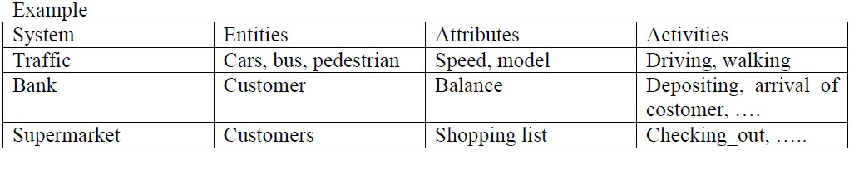
For instance, an endogenous event in the example is the beginning of service of the customer since that is within the system being simulated. An exogenous event is the arrival of a customer for service since that occurrence is outside of the simulation.

State variables
The state of a system is defined to be that collection of variables necessary to describe the system at any time, relative to the objectives of the study. In the study of a bank, possible state variables are the number of busy tellers, the number of customers waiting in line or being served, and the arrival time of the next customer. So the system state variables are the collection of all information needed to define what is happening within the system to a sufficient level (i.e., to attain the desired output) at a given point in time.

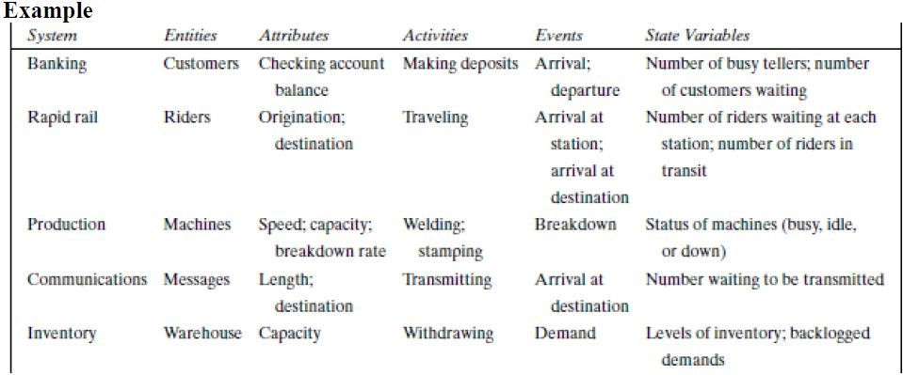

Endogenous System
The term endogenous is used to describe activities and events occurring within a system. Example: Drawing cash in a bank.

Exogenous System
The term exogenous is used to describe activities and events in the environment that affect the system. Example: Arrival of customers.

Open System/Close System
A system with exogenous activities is considered as open system and a system with strict endogenous activities is called a closed system.

2. System Environment
System Environment
The system environment includes everything external to the system that interacts with it, influences it, or is influenced by it. It forms the broader context in which the system operates and can shape both the system’s behavior and its long-term performance.
Environmental factors can be physical, social, economic, or regulatory. Physical factors include temperature, weather, geography, and available resources. Social factors include user behavior, culture, organizational norms, and communication patterns. Economic factors include costs, prices, demand, competition, and funding. Regulatory factors include laws, policies, standards, and compliance requirements.
System boundaries help define what is inside the system and what belongs to the environment. A boundary separates the components that are directly part of the system from external influences that act on it. For example, in a business, employees, equipment, and internal processes may be inside the boundary, while customers, suppliers, market conditions, and government regulations are outside it.
The environment affects system behavior by changing the inputs a system receives and the conditions under which it operates. A transportation system, for example, behaves differently during heavy rain, rush hour, or road closures. A hospital system may be affected by seasonal illness, staffing shortages, or new health regulations. These changes can alter system performance, stability, and efficiency.
There is also feedback between systems and their environments. A system does not just react passively; it can change its environment as well. For instance, a manufacturing system may increase pollution, which then leads to stricter environmental regulation. A social media platform may shape user behavior, which in turn changes the surrounding social environment and future usage patterns.
Understanding the environment is essential for modeling and simulation because a model must represent the external conditions that influence the system. If the environment is ignored or oversimplified, simulations may produce unrealistic results. Accurate environmental modeling helps predict system responses, identify risks, test scenarios, and improve decision-making under changing conditions.

Example: In a factory system, the factors controlling arrival of orders may be outside the factory but is a part of the system environment. When, we consider the demand and supply of goods, there is certainly a relationship between the factory output and arrival of orders. This relationship is considered as an activity of the system.

4. Continuous and Discrete system
Systems can be modeled in two broad ways depending on how they change over time. The choice of model depends on whether the system evolves smoothly or in distinct steps.
- Continuous Systems: Change smoothly over time, with values defined at every moment. They are often represented by differential equations and are useful when changes are gradual and ongoing.
For example, during winter seasons level of which water decreases gradually and during rainy season level of water increase gradually. The change in water level is continuous.
The figure below shows the change of water level over time.
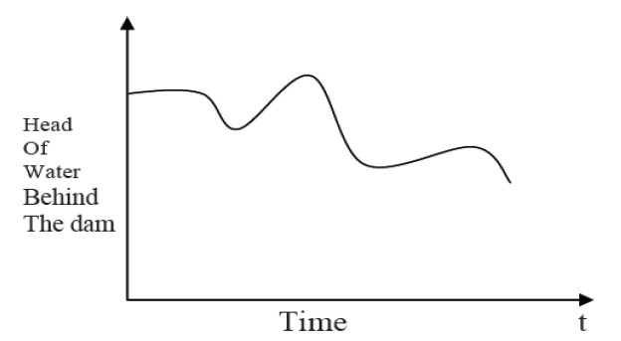

- Discrete Systems: Change at specific points in time or through individual events. They are typically modeled using states, counts, or event-based methods, making them ideal for systems with separate occurrences.

The figure below shows how no of customer changes only at discrete points in time.

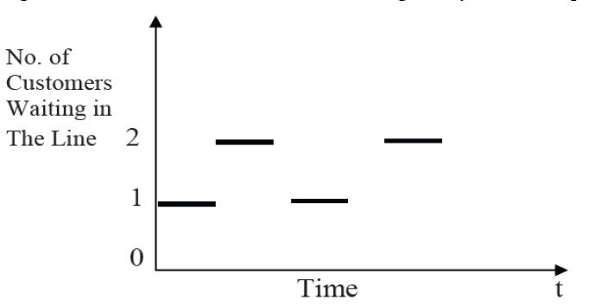

Example of a discrete system: customer arrivals at a store, where people enter one at a time, or the number of items in inventory, which changes in whole units.

Continuous systems are usually analyzed with mathematical tools such as differential equations, calculus, and numerical methods. Discrete systems often use event-based modeling, state machines, recurrence relations, or queueing models to track changes step by step.
These systems behave differently: continuous systems are smooth and often predictable over short intervals, while discrete systems are piecewise and jump from one state to another. Continuous models are good for approximating physical processes, while discrete models are better for counting, scheduling, and logical transitions.
Use continuous models when the quantity changes gradually, such as motion, heat transfer, fluid flow, electrical circuits, or population growth. Use discrete models when the system changes through separate events, such as customer traffic, computer networks, manufacturing steps, or traffic lights.
In real-world applications, continuous systems are common in physics, engineering, chemistry, and climate modeling. Discrete systems are widely used in operations research, computer science, business process simulation, and telecommunications.

5. System Modeling
System modeling is the process of creating a simplified representation of a real-world system so it can be studied more clearly. A model captures the most important parts of a system while leaving out unnecessary detail, making complex behavior easier to work with.
- Purpose: Models help analyze how a system works, improve understanding of its structure and behavior, and predict how it may respond under different conditions.
- Why it matters: By reducing complexity, system modeling supports better decision-making, safer testing, and more effective design improvements before changes are made in the real world.
- Modeling process: Define the problem, identify key variables and relationships, choose a modeling approach, build the model, test it against real behavior, and refine it as needed.
- Common approaches: System modeling can be qualitative or quantitative, static or dynamic, and deterministic or stochastic depending on the goals and available data.
- Types of models: Examples include physical models, conceptual models, mathematical models, simulation models, and computational models.
- Real-world connection: A good model does not replicate every detail of reality; instead, it balances simplicity and accuracy so the model remains useful for the task at hand.
- What it helps achieve: System modeling can reveal patterns, test scenarios, compare design options, forecast outcomes, and improve performance before implementation.

6. Types of Models
- Visual Models: Graphical sketches, diagrams, and computer-based solid models that show structure, layout, or relationships at a glance. Examples include engineering drawings, flowcharts, architectural renderings, and 3D CAD models. They are most useful in early design and communication because they make ideas easy to understand and share. Their strengths are clarity, speed, and accessibility, but they may not capture behavior or precise performance on their own.
- Physical Models: Tangible, scaled representations of real-world systems that can be held, examined, and tested. Examples include a bridge prototype, a topographic model, a model airplane, or a classroom solar system model. They are most useful when shape, size, and spatial relationships matter, and they offer strong intuition through direct observation. Their advantages include realism and hands-on testing, but they can be expensive, time-consuming to build, and limited in how much detail they can represent.
- Mathematical Models: Equations, formulas, and algorithms that represent how a system behaves. Examples include population-growth equations, supply-and-demand curves, projectile-motion formulas, and weather prediction models. They are most useful when you need to quantify relationships, estimate outcomes, or compare scenarios precisely. Their strengths are rigor, repeatability, and the ability to test many conditions quickly, but they depend on assumptions and can oversimplify complex real-world behavior.
- Simulation Models: Computational methods that imitate real-world processes over time so you can observe behavior under different conditions. Examples include traffic-flow simulations, pandemic spread models, factory production simulations, and flight simulators. They are most useful when a system is too complex, risky, or expensive to test in reality. Their advantages include flexibility, safe experimentation, and insight into dynamic behavior, but results are only as good as the underlying data, rules, and assumptions.
These model types are often used together rather than in isolation. A visual model may help define the structure of a problem, a physical model can validate size or form, a mathematical model can describe the underlying relationships, and a simulation model can show how the system changes over time. Using them together creates a more complete understanding: visual and physical models improve communication, while mathematical and simulation models improve analysis and prediction.
In practice, the best choice depends on the goal. If the priority is explanation, use a visual model. If the priority is hands-on testing, use a physical model. If the priority is precision, use a mathematical model. If the priority is exploring complex behavior, use a simulation model. Each approach has strengths and limitations, so combining them often produces the most reliable results.

Deterministic Model
A deterministic model is a model in which the output is completely determined by the input and the initial conditions. It does not include randomness or probability, so the same input will always produce the same result.
- A model that does not contain probability or random variation
- Every run with the same inputs will result in the same outcome
- Single runs are often enough to evaluate the result when the system is fully known
- Highly predictable and reproducible, because the same conditions always lead to the same output
- Usually based on fixed rules, equations, or logical relationships
Deterministic models are common in engineering, physics, mathematics, and some areas of finance. Examples include structural load calculations in engineering, projectile motion in physics, and compound interest calculations in finance. In each case, the model follows defined formulas rather than random processes.
These models are useful when the system is well understood and the main relationships between variables can be described accurately. They are often easier to test, verify, and interpret than probabilistic approaches, and they provide consistent results that are easy to reproduce.
However, deterministic models have limitations. They may oversimplify real-world systems, especially when uncertainty, noise, or human behavior plays an important role. If the underlying assumptions are wrong or the system changes over time, the model may give misleading results.
Deterministic models differ from stochastic models, which include randomness and produce a range of possible outcomes rather than one fixed answer. Stochastic models are better when uncertainty is significant, such as in weather forecasting, population growth, risk analysis, or queueing systems.
In general, deterministic models are best used when predictability, clarity, and reproducibility are important and the system can be described with confidence. When uncertainty is high or outcomes vary naturally, a stochastic model may be the better choice.
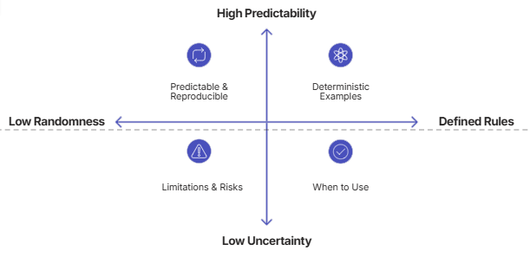

Stochastic Model
Stochastic model
A stochastic model is a model that incorporates randomness, uncertainty, or variation in the system being studied. Unlike a deterministic model, which always produces the same output for the same input, a stochastic model allows outcomes to vary and describes them using probabilities. This makes stochastic models especially useful when real-world behavior is influenced by noise, chance, incomplete information, or inherently variable processes.
- Stochastic models involve randomness or uncertainty in system behavior
- They use probability distributions to represent uncertain outcomes and event likelihoods
- The same inputs can produce different results across multiple runs
- They are often analyzed statistically rather than through a single predicted outcome
Probability distributions are central to stochastic models. They describe how likely different outcomes are, such as the chance of an event occurring, the spread of possible values, or the expected variation around an average. Common distributions include normal, binomial, Poisson, and exponential distributions, each useful for different kinds of random processes.
Stochastic models appear in many fields. In weather forecasting, they help represent uncertain changes in temperature, rainfall, and storm paths. In finance, they are used to model stock prices, interest rates, and investment risk. In biology, they help describe population growth, gene expression, and the spread of disease. They are also common in operations research, queueing systems, traffic flow, and simulation of complex systems.
These models are appropriate when uncertainty is an important part of the problem or when the system is too complex to describe exactly. They are especially useful when analysts want to estimate risk, compare likely outcomes, or understand a range of possible scenarios rather than a single answer. Because the output varies, stochastic models are usually run many times, and the results are summarized using averages, probabilities, confidence intervals, or other statistical measures.
The main advantage of stochastic models is that they can reflect real-world variability more realistically than deterministic models. They are valuable for simulation, forecasting under uncertainty, decision-making, and risk analysis. They also help quantify how sensitive a system is to random effects or uncertain inputs.
However, stochastic models also have limitations. They can be more complex to build, require more data, and may be harder to interpret than deterministic models. Their results are not a single fixed answer, so they often need multiple runs and careful statistical analysis to draw reliable conclusions. The quality of the model depends heavily on whether the chosen probability distributions and assumptions accurately represent reality.
In general, stochastic models are best used when uncertainty, randomness, or natural variation is important to the problem. Deterministic models are better when relationships are well known and outcomes are fully predictable. In practice, both approaches are often used together: deterministic structure can describe the system, while stochastic elements capture the uncertainty around it.

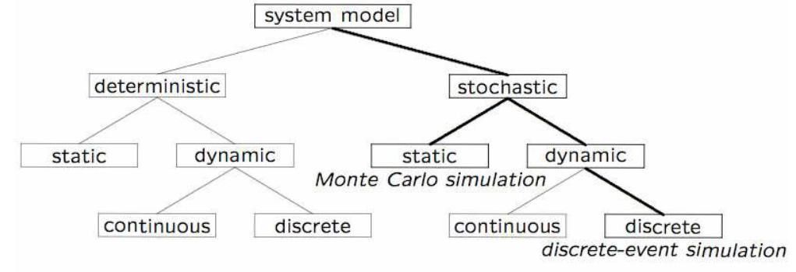
Fig: System Hierarchy based on input

7. Principles used in Modeling
Guidelines used in modeling
It is not possible provide rule by which models are built. But several guidelines can be stated.
The different viewpoints from which we can judge whether certain info. Should be included as excluded in models are:

- Block –Building: The description of system should be organized as a sequence of blocks. It simplifies the interaction between block within system. Then it will be easy to describe the whole system in terms of interaction between the block and can be represented graphically as simple block diagram. For example: -the block of factory system. Fig: Block diagram of factory system

- Relevance: The model should only include relevant information. For example, if the factory system study aims to compare the efficient of different operating rules efficiency it is not relevant to consider the mining of employee as an activity. Irrelevant information should not include despite of being no harm because it increases the complexity of model and takes more time and effort to solve model.

- Accuracy: The gathered information should be accurate as well. For example, in aircraft system the accuracy as movement of the aircraft depends upon the representations of airframe such as a rigid body.

- Aggregation: It should be considered that to which numbers of individual entities can be grouped into a block. For example, in factory system, different department are grouped together handled by production manager.

Advantages of simulation
- Simulation can also be used to study systems in the design stage.
- Simulation models are runner rather than solver.
- New policies, operating procedures, decision rules, information flow, etc. can be explored without disrupting the ongoing operations of the real system.
- New hardware designs, physical layouts, transportation systems can be tested without committing resources for their acquisition.
- Hypotheses about how or why certain phenomena occur can be tested for feasibility.
- Time can be compressed or expanded allowing for a speedup or slowdown of the phenomena under investigation.
- Insight can be obtained about the interaction of variables.
- Insight can be obtained about the importance of variables to the performance of the system.
- Bottleneck analysis can be performed indication where work-in process, information materials and so on are being excessively delayed.

Disadvantage of simulation
- Model building requires special training.
- Simulation results may be difficult to interpret.
- Simulation modeling and analysis can be time consuming and expensive.
- Simulation is used in some cases when an analytical solution is possible or even preferable.

8. Areas of Applications
- Military Training: Simulation supports mission rehearsals, battlefield training, and virtual combat scenarios so personnel can practice tactics safely. It reduces risk, lowers training costs, and improves readiness before real deployments.
- Engineering: Engineers use modeling for stress testing, design validation, and prototyping of structures, machines, and electronic systems. This helps identify failures early, improve performance, shorten development time, and reduce material waste.
- Traffic Systems: Traffic simulations are used for intersection design, signal timing, highway planning, and congestion analysis. They help optimize flow, reduce travel delays, improve safety, and support smarter infrastructure decisions.
- Healthcare and Pharma: Simulation assists in hospital workflow planning, patient flow analysis, drug development, clinical trial design, and dose optimization. It can speed up research, improve treatment planning, reduce costs, and support better patient outcomes.
- Business Process Modeling and Service Systems: Organizations model workflows for customer service, order fulfillment, call centers, and administrative operations. This reveals bottlenecks, improves efficiency, increases service quality, and supports better resource allocation.
- Manufacturing and Production: Manufacturers use simulation for factory layout design, production line balancing, machine scheduling, and quality control. It improves throughput, reduces downtime, limits defects, and helps scale operations with less disruption.
- Marketing and Competition: Businesses model customer behavior, pricing strategies, campaign performance, and competitive responses. These models improve decision-making, forecast demand, identify profitable segments, and strengthen market positioning.
- Project and Asset Management: Simulation helps plan project timelines, evaluate risk, allocate budgets, and manage equipment lifecycles. It improves forecasting, reduces schedule overruns, and supports more reliable long-term asset performance.
- Supply Chains and Logistics: Companies simulate inventory policies, warehouse operations, transport routes, and disruption scenarios. This helps reduce costs, improve delivery reliability, strengthen resilience, and optimize end-to-end flow.
- Environmental and Climate Studies: Modeling is used for weather prediction, flood planning, pollution tracking, and climate impact analysis. It helps decision-makers prepare for environmental risks, protect communities, and design more sustainable policies.
- Education and Research: Simulations support interactive learning, lab experiments, scientific experimentation, and hypothesis testing. They make complex concepts easier to understand, allow safe experimentation, and accelerate discovery.
- Urban Planning and Smart Cities: Planners use models to test land use, housing growth, energy demand, public transit, and emergency response. This leads to better city design, improved livability, and more efficient public services.

9.Verification and Validation of Models

Verification and Validation (V&V) are essential elements in the modeling and simulation process that guarantee a model functions correctly and accurately depict the real-world system. Though they frequently happen simultaneously, they have different goals:

1. Verification
"Are we building the system, right?"
- Purpose: Ensures the implementation of the model or system is done correctly, meaning the code, logic, formulas, and procedures match the intended design.
- Focuses on internal correctness — checking whether the system was built according to specifications, without asking yet whether it solves the real-world problem.
- Helps catch issues early, such as missing logic, incorrect calculations, broken assumptions, or mistakes introduced during development.
- Often involves checking whether each component behaves as expected on its own and whether the system produces the right outputs for known inputs.
- Is especially important when a system has multiple steps, rules, or dependencies, because a small coding error can affect the entire result.
- Often involves:
  - Code reviews: Other developers inspect the code to confirm that it follows the design, uses the correct logic, and avoids obvious implementation mistakes. This can also reveal missing edge cases or inconsistent assumptions.
  - Debugging: Testing and tracing the system step by step to find and fix defects, such as incorrect variable values, broken conditions, or unexpected behavior.
  - Unit testing: Verifying small pieces of code individually to make sure each function or module produces the expected result under normal and edge-case inputs.
  - Comparing outputs with known expected results: Running the system on test cases where the correct answer is already known, then checking whether the output matches. This is useful for confirming accuracy in calculations and logic-heavy models.
  - Integration testing: Checking whether separate modules work correctly when connected together, especially when data is passed from one part of the system to another.
  - Regression testing: Repeating tests after changes are made to make sure new updates did not break something that previously worked.
Example
If you're programming an AI to play chess, verification ensures the rules are correctly coded and the AI moves pieces legally. For example, it checks that a bishop moves only diagonally, a pawn cannot jump forward through another piece, and the system does not allow two pieces to occupy the same square.
Verification would also test whether the move generator, scoring rules, and turn logic work exactly as intended before the AI is ever judged on how well it plays against human opponents.
This matters because even a very advanced strategy engine is not useful if it is built on faulty logic. Verification helps ensure the system is technically sound, so later evaluation can focus on performance, fairness, and usefulness with confidence.

2. Validation
Validation
"Are we building the right system?"
- Purpose: Ensures the model or system represents the real-world process or scenario it's meant to simulate, predict, support, or improve.
- Focuses on external correctness — whether the system behaves in a way that is believable, useful, and accurate when compared to real-world outcomes, not just whether it works according to its internal design.
- Checks whether the system is actually solving the right problem for the intended users, in the intended environment, with the intended constraints.
- Helps confirm that assumptions made during development match reality, including user behavior, domain rules, data patterns, and practical operating conditions.
- Often reveals gaps between a technically functional system and one that is genuinely useful, trustworthy, or meaningful in practice.
- Often involves:
- Comparing model results with real-world data to see whether predictions, classifications, or recommendations align with observed outcomes.
- Stakeholder feedback from end users, subject-matter experts, or decision-makers to confirm that the system reflects real needs and expectations.
- Performance analysis across meaningful scenarios, such as testing whether the system remains accurate under different conditions, edge cases, or user groups.
- User testing: Asking real users to interact with the system and reporting whether it solves their problem in a practical, intuitive way.
- Field trials or pilot studies: Deploying the system in a limited real-world setting to observe how it performs outside the lab or test environment.
- Back-testing: Checking whether the model would have made sound decisions on historical data or past events.
- Expert review: Having domain experts evaluate whether outputs make sense, reflect reality, and support real decision-making.
- A/B testing: Comparing the system against an existing approach or alternative version to see which one produces better real-world results.
- Scenario testing: Evaluating how the system behaves under realistic situations, including unusual or high-stakes cases that matter to users.
Validation is critical because a system can be built correctly and still be the wrong solution. A model may be internally consistent, but if it does not reflect real-world behavior, it can lead to poor decisions, wasted effort, false confidence, or missed opportunities. In practical settings, validation protects against building something that looks impressive in testing but fails when people rely on it.
When validation is skipped, teams may optimize for the wrong goal, overfit to unrealistic test conditions, or misunderstand what users actually need. That can result in products that are accurate on paper but ineffective in the real world, or systems that produce outputs no one trusts or can use. In high-stakes domains, such as healthcare, finance, hiring, transportation, or safety systems, the consequences can be especially serious.
Different validation approaches serve different purposes. Quantitative validation compares outputs against measurable ground truth, while qualitative validation focuses on expert judgment and user experience. Some teams validate early with prototypes, while others validate later with pilots or live deployment. The best approach usually combines multiple methods to ensure the system works not only in theory, but also in practice.
Example
In the chess AI case, validation checks whether the AI plays like a real chess player in ways that matter to the intended use. It is not enough for the program to move pieces legally — it should also make sensible strategic choices, respond appropriately to different openings, adapt to opponents of different skill levels, and show behavior that matches the goals of the system.
For example, validation might compare the AI's move choices against grandmaster games, test whether its strategies improve against stronger opponents, or see whether it makes mistakes that are plausible for a human player at a similar skill level. If the AI is meant to help beginners learn, validation may also check whether its advice is understandable, timely, and useful. If it is meant to be a competitive engine, validation may focus on whether it performs well against established benchmarks and real opponents.
Validation would also examine whether the AI behaves appropriately in realistic situations: does it recognize common tactical patterns, avoid obviously human-unfriendly moves, and respond consistently across openings, midgame positions, and endgames? This broader testing ensures the system is not only correct in a technical sense, but also aligned with the real-world purpose it was designed to serve.
This matters because a chess AI that is technically well-built but strategically weak, unrealistic, or unhelpful may fail its users even if its code is flawless. Validation helps ensure that what was built is actually the right system for the problem, so the final product has value outside the test environment.
Examples:
- Validating a climate model by comparing its predictions with actual historical climate data.
- Validating a business process simulation by comparing model outputs with observed performance metrics from the business.

Importance of V&V:

- Reliability: Ensures the model can be trusted to produce accurate and useful results.
- Model Confidence: Increases the confidence of stakeholders in the simulation outcomes.
- Risk Mitigation: Reduces the risk of making decisions based on faulty models, which could lead to undesirable consequences.

Differences Between Verification and Validation:
- Verification checks the correctness of the model's implementation.
- Validation checks the accuracy of the model's representation of reality.

In summary:
- Verification ensures the model works as intended.
- Validation ensures the model is accurate and useful in representing the real-world system or process.

As a final piece of advice, remember that there is no one-size-fits-all simulation plan for every problem. The team’s situation may seem unique, and thus, an equally unique approach to make may be necessary to achieve success.
The steps outlined above aren’t set in stone – they may be reshaped and adjusted in any way to adapt to the project! Slightly different formulations of the simulation process may be discovered online – choose one that appears to be the best match to the problem at hand.
Simple vasa ma, this is not exact solution for any simulation, you will modify solution according to your need.

